Objectives:

* Inheriting classes
* Calling classes

**There are 3 challenge exercises, each worth 33.3%**

Separating classes is a way to distribute code in an efficient manner where the main method can call multiple classes from one location.

**When is a Constructor called?**  
Each time an object is created using **new()** keyword at least one constructor (it could be default constructor) is invoked to assign initial values to the **data members**of the same class.

className variableName = new className();

className is the method class

**Accessor Methods?**

Is a **get/getter** **method** which is the property of the object is returned by the accessor method.

The class that is being called is called the access modifier class, because it can be accessed by the main method and modified

**Mutator Methods?**

Used to control changes to a variable. Widely used as **setter method.**

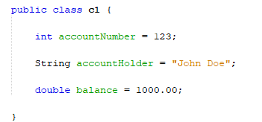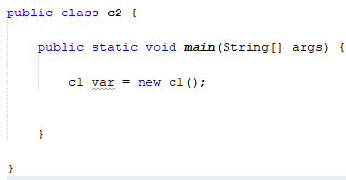

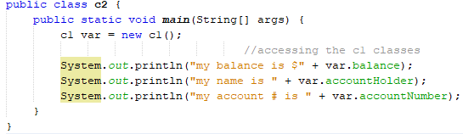

Change the double balance from public to private as shown below

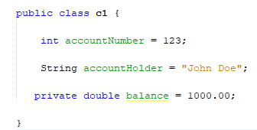

Switch to the main class and notice the balance cannot be seen anymore

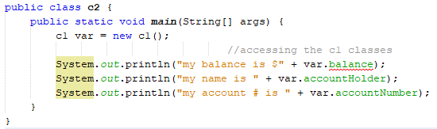

Creating the access modifier method, remember, its called the get or getter starting with **double getBalance()**

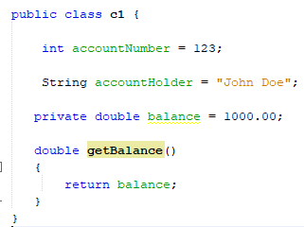

Switch to the main method and call the getBalance **access** modifier

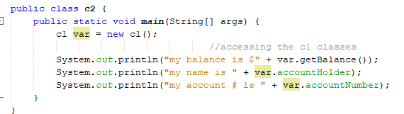

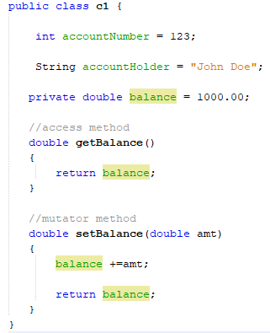

Mutator method which is called the setter method

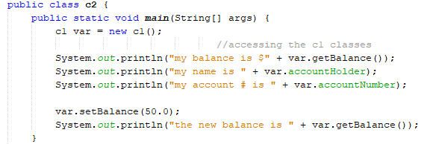

**Letters a-b are related**

1. Name the 1st class, **r1**

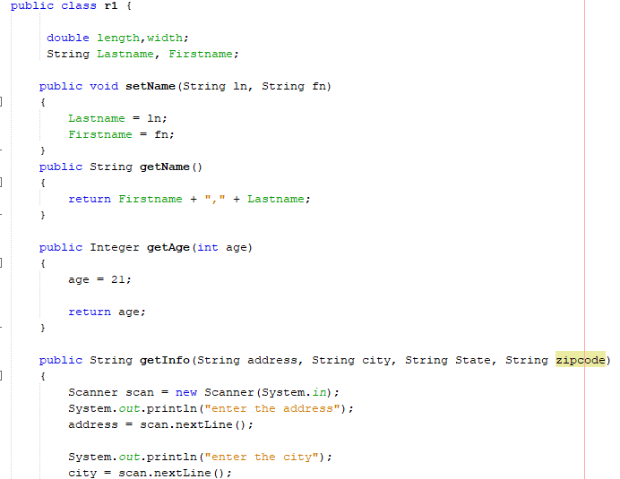

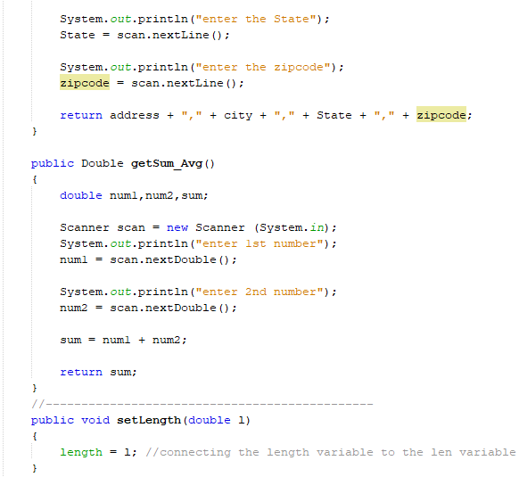

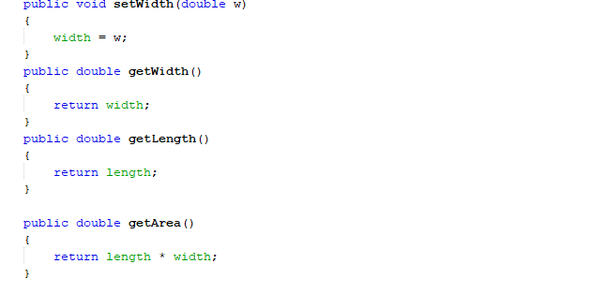

1. Name the 2nd class, **r2**

R1 var = new r1, is the constructor

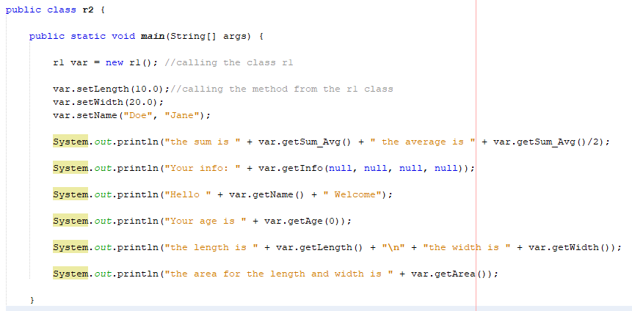

**Challenge Exercise #1:** complete the (UML Diagram), create two classes.

**#1 print screen the output with the code below here**

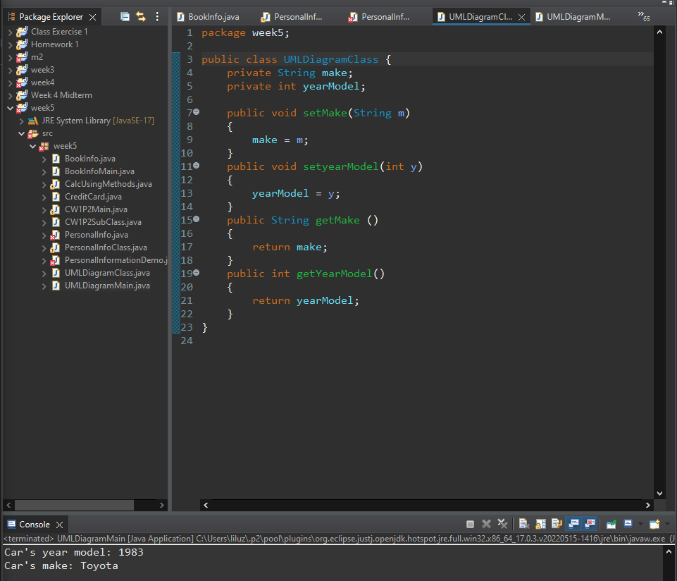

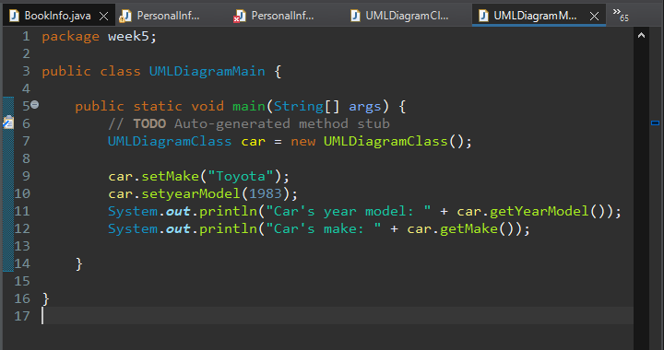

**Questions 1-2 are related**

1. Name the class, **Students** without the main method

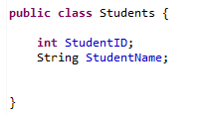

1. Create a 2nd class and name it **GetStudents** including the main method

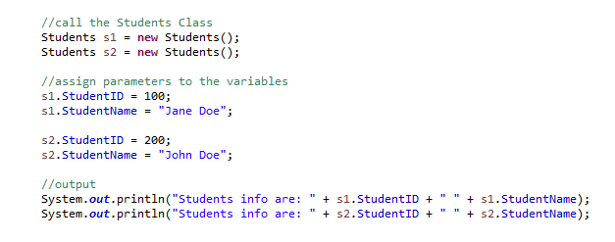

**Questions 3-4 are related**

1. Create a new class and name it **MathClass** without a main method

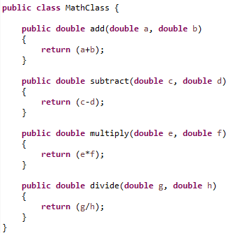

1. Create a new class and name it **GetMathClass** with the main method

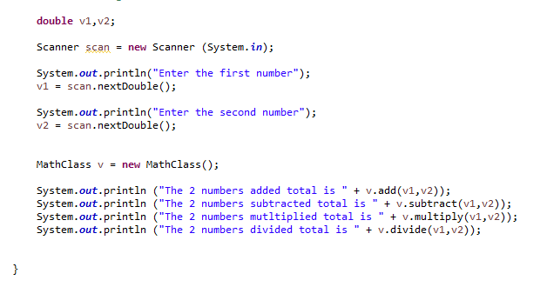

**Questions 5-7 are related**

1. Name the 1st class, **Multiplication** without the main method

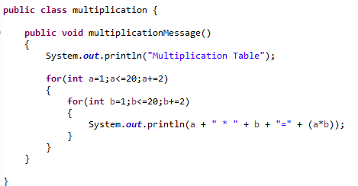

1. Name the 2nd class, **Addition** without the main method

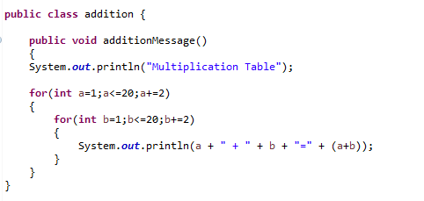

1. Name the 3rd class, **CallMultiplicationAddition** with the main method, here we are calling classes Multiplication and Addition

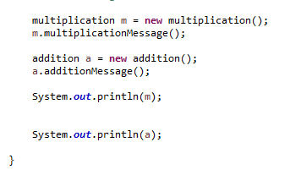

**Challenge Exercise #2:** Complete the algorithm workbench below. Be sure to create 2 classes.

**#2 print screen the output with the code below here.**

**Challenge Exercise #3:** Complete the algorithm workbench below. Be sure to create 2 classes.

**#3 print screen the output with the code below here.**

**Submit this document to Module 5 Class Exercise.**